1. Which are the top three variables in your model which contribute most towards the probability of a lead getting converted?

Ans-: Three Variables are:-

1. Tags_Lost to EINS
2. Tags_Closed by Horizzon
3. Tags_will revert after reading the email
4. What are the top 3 categorical/dummy variables in the model which should be focused the most on in order to increase the probability of lead conversion?

Ans-: Three Variables are:-

* 1. Tags_Lost to EINS
  2. Tags_Closed by Horizzon
  3. Tags_will revert after reading the email

1. X Education has a period of 2 months every year during which they hire some interns. The sales team, in particular, has around 10 interns allotted to them. So during this phase, they wish to make the lead conversion more aggressive. So they want almost all of the potential leads (i.e. the customers who have been predicted as 1 by the model) to be converted and hence, want to make phone calls to as much of such people as possible. Suggest a good strategy they should employ at this stage.

Ans-: Sensitivity with admire to our model can be defined as the ratio of total range of actual Conversions efficaciously predicted to the overall no of actual Conversions.

in addition, Specificity may be described because the ratio of overall no of actual non-Conversions efficiently anticipated to the total quantity of real non-Conversions.

For a specific version, as one will increase, the other decreases and vice versa.

exceptional values of the sensitivity and specificity can be completed for the identical model by way of converting the Conversion chance cutoff threshold fee.

For our version, the under graph suggests how the Sensitivity and Specificity rating adjustments with change within the threshold price:

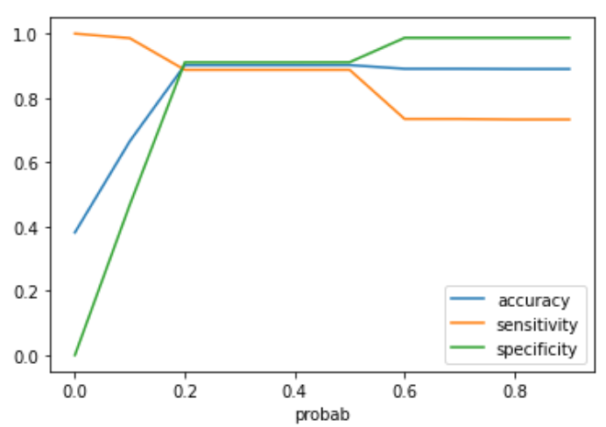

whilst the probability thresholds are very low, the sensitivity is very excessive and specificity may be very low. similarly, for large possibility thresholds, the sensitivity values are very low but the specificity values are very high.

high sensitivity implies that our version will correctly pick out nearly all leads who are probably to transform. it will try this by means of over-estimating the Conversion probability, i.e. it's going to misclassify some non-Conversion cases as Conversions.

Now, due to the fact X education has greater guy-electricity for these 2 months and they want to make the lead conversion extra competitive through wanting nearly all of the ability leads, we will select a lower threshold price for Conversion possibility.

this may ensure the Sensitivity score could be very high which in flip will make certain almost all leads who're probably to transform are diagnosed effectively and the agents could make phone calls to as much of such people as viable.

1. Similarly, at times, the company reaches its target for a quarter before the deadline. During this time, the company wants the sales team to focus on some new work as well. So during this time, the company’s aim is to not make phone calls unless it’s extremely necessary, i.e. they want to minimize the rate of useless phone calls. Suggest a strategy they should employ at this stage.

Ans:- Following the similar logic and context from the preceding query, excessive Specificity implies that our version will efficaciously perceive almost all leads who aren't likely to transform. it will do that on the value of dropping out a few low Conversion rate risky leads to the competition, i.e. it's going to misclassify some Conversion cases as non-Conversions.

Therefore, when you consider that X training has already reached its goal for 1 / 4 and doesn’t need to make phone calls except it’s extremely important, i.e. they want to limit the rate of useless cellphone calls, we will select a higher threshold value for Conversion probability.

This can make sure the Specificity rating is very high, which in flip will ensure almost all leads who're getting ready to the chance of getting converted or no longer aren't decided on. As a result the marketers won’t should make unnecessary cellphone calls and may cognizance on a few new works.